1. Minsupport: it really depends on how many sequences are similar in the dataset.

Minconfidence: it depends on how much confidence I want in the rule. It depends on the people

1. The rules are generated with “rules <- apriori(Groceries, parameter = list(supp = 0.001, conf = 0.8))” which means use groceries data with minimum support 0.001 and minimum confidence 0.8.

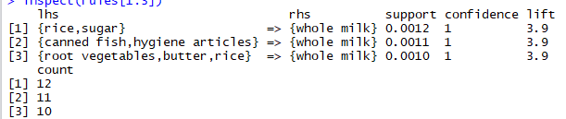

1st rule: find 12 in dataset, people bought rice and sugar would buy whole milk, 0.12% happened among whole dataset. And the confidence is 1 which mean people will 100% buy whole milk if they bought rice and sugar. The life is 3.9, which means the rule body and the rule head appear more often together than expected

2nd rule: find 11 in dataset, people bought canned fish,hygiene articles would buy whole milk, 0.11% happened among whole dataset. And the confidence is 1 which mean people will 100% buy whole milk if they bought rice and sugar. The life is 3.9, which means the rule body and the rule head appear more often together than expected

3rd rule: find 10 in dataset, people bought rice and sugar would buy whole milk, 0.1% happened among whole dataset. And the confidence is 1 which mean people will 100% buy whole milk if they bought rice and sugar. The life is 3.9, which means the rule body and the rule head appear more often together than expected

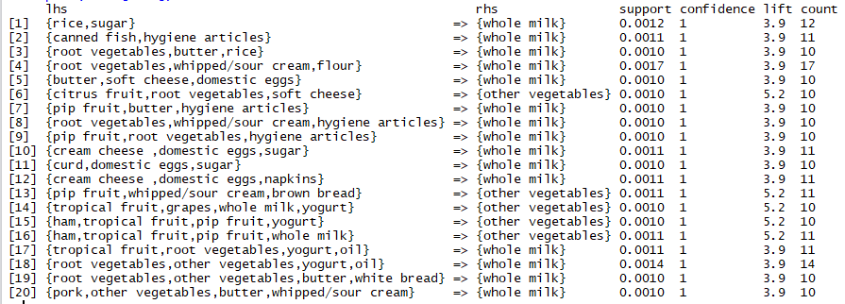

For supermarket, they could propose several packages. For example, could have one package that have rice sugar and whole milk, sell them together. Or for customer’s convenience, they could put rice sugar and milk at the same area or put them close in supermarket. They could also have promotions like, if you bought rice and sugar, the whole milk would be 80% off.